Ask for ID.
Enter data into all fields for which you have data in the ClientPoint search form and click “Search”.
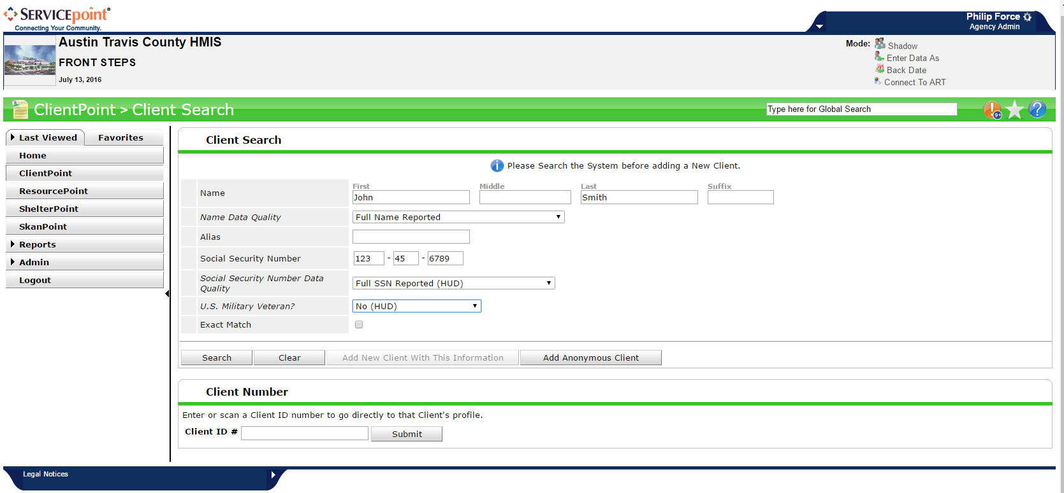
If no matching profile comes up, go through the HMIS ROI with client. This ROI gives us permission to enter his/her information into the database. If the client refuses to sign the ROI, you will need to create an anonymous profile. Do so by clicking “Add Anonymous Client”. If your client is already in the system, please go to his/her client profile tab to be sure an intake has not yet been collected.

If an intake has been collected, it should be uploaded under the File Attachments section
and the dates in the section below should hold a value other than “Select”:
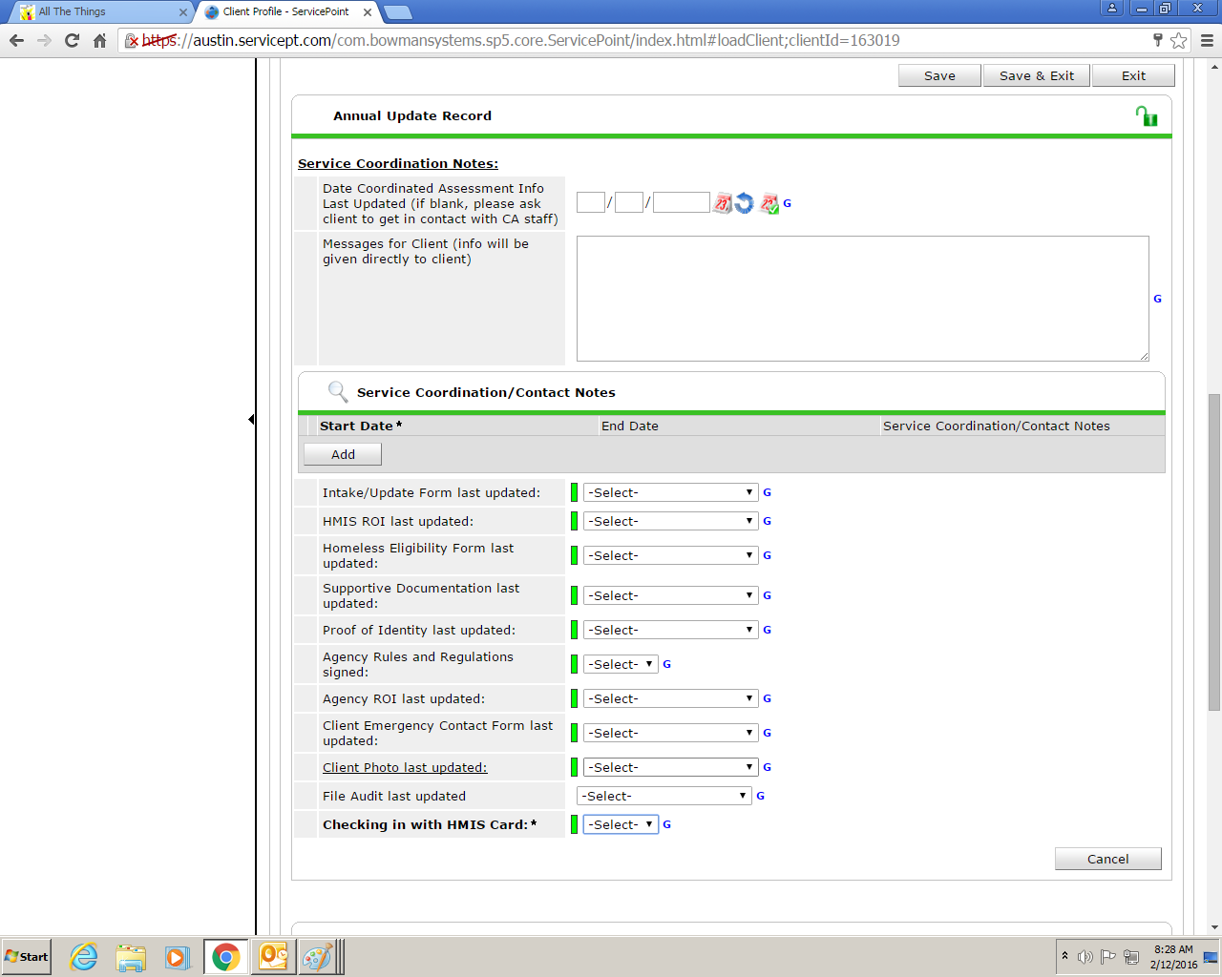
If there is no uploaded intake and the dates section is blank, please continue with the Intake packet. If there is an Intake packet uploaded and today’s date does not fall between the dates listed in the dates section in the image above, you may need to do an Annual Assessment instead of an Intake. You will use the same forms, but will change a few steps in the process.
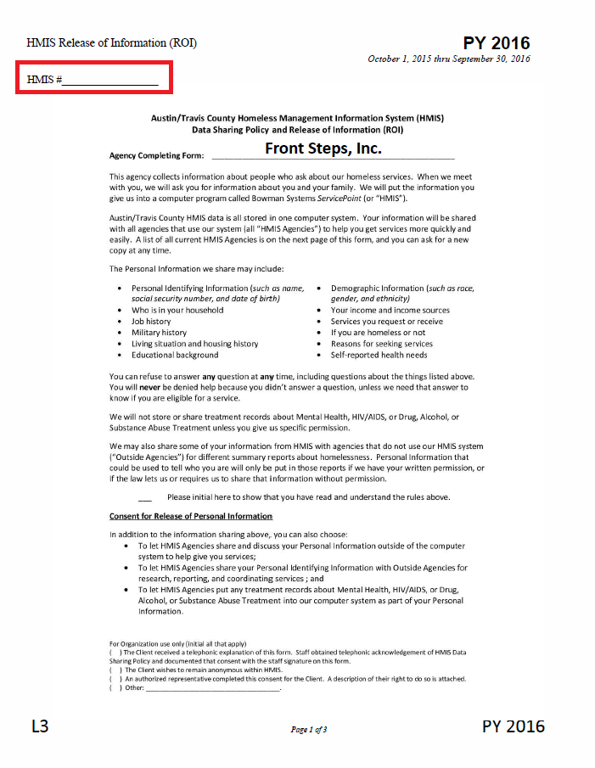
If you are completing an Intake and not an Annual Assessment, you will have to return to fill in this info after you have created the client’s profile. If you are doing an Annual Assessment, you should already have this info.
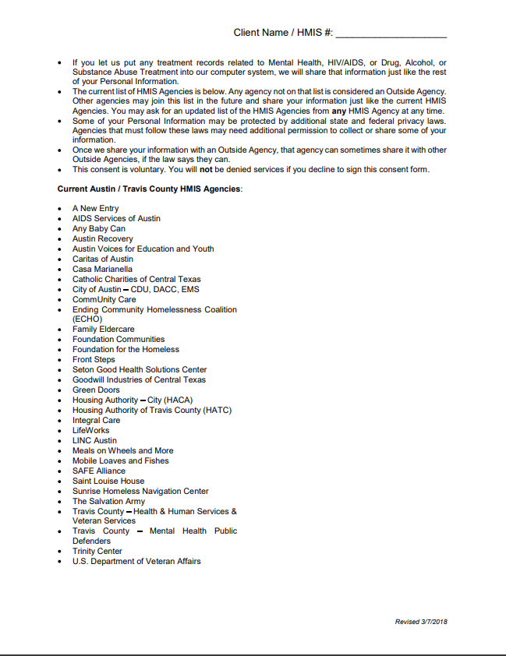
This page lists all of the organizations that currently have access to the Travis County HMIS system.
Be sure to fill out every other field.
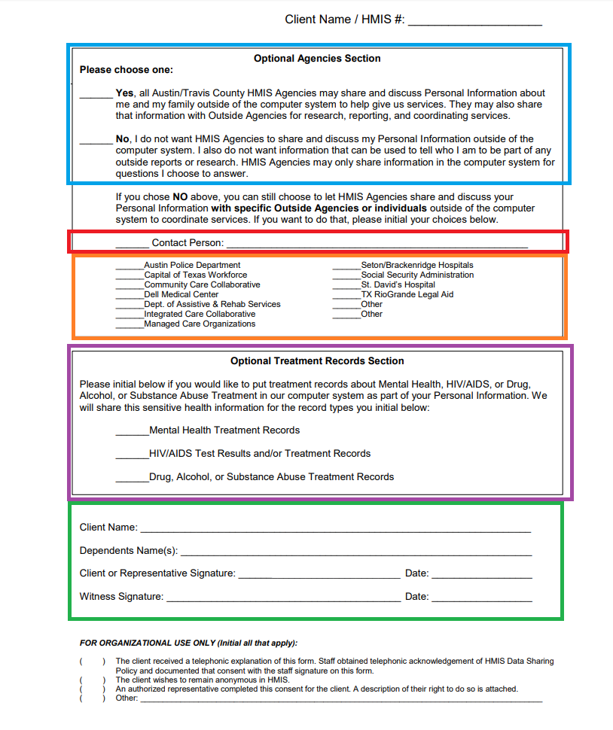
If the client would like for us to be able to communicate with anyone outside of the database, like via phone or email, or if the client would like for us to be able to coordinated services with any of the organizations who have access to the database, he/she will need to initial the “Yes” line. If not, he/she will need to initial the “No” line.
Here, the client can list a backup contact. This is a person organizations who have access to ServicePoint can contact if they are trying to get in touch with the client.
Here is a list of organizations who do not have access to the HMIS database. The client can initial on the lines next to any of these organizations if he/she would like for us to be able to communicate with them.
If the client has received treatment for mental health, drug or alcohol abuse, or HIV or AIDS and has paper copies of treatment records they would like for us to upload into ServicePoint, they can initial on the appropriate lines.
Have the client print his/her name on the “Client Name” line. If the client has any dependents who will receive services with Front Steps, he/she can print the names of his/her dependents on the “Dependent Name” line. The client will then need to sign and date on the “Client or Representative Signature” line. Please insure you sign and date on the “Witness Signature” line.
If you are completing an Intake for a client who does not wish to be anonymous, you can now create a profile for your new client.
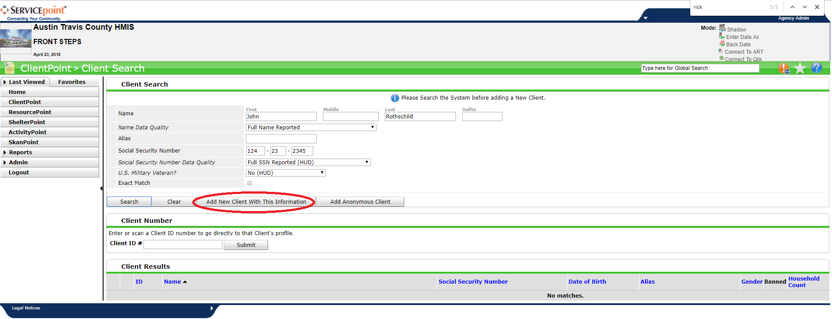
You will then be given a ServicePoint number for your new client. Please go back and enter this new number on the 3 ROI pages and on all pages that request it going forward.

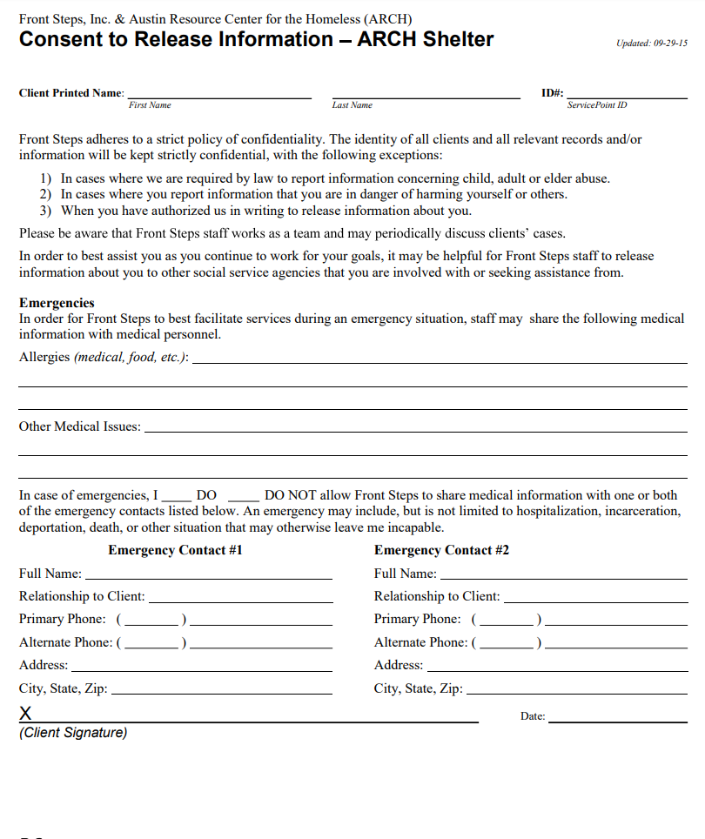
On the “Consent to Release Information – ARCH Shelter” page, please enter client’s first and last names and SP number at the top. Document if the client has any food or medical allergies and whether the client has any other medical issues. If the client has an emergency contact they would like Front Steps to have, please have them initial next to “DO” and fill in contact info for one or both of the Emergency Contacts below. Please have the client sign and date at the bottom.

While they are filling out the “Consent to Release Information – ARCH Shelter” page, you can go through their “Client Profile” tab and fill out some of the required fields.
Scroll down and select dates from the fields listed in the screenshot above.
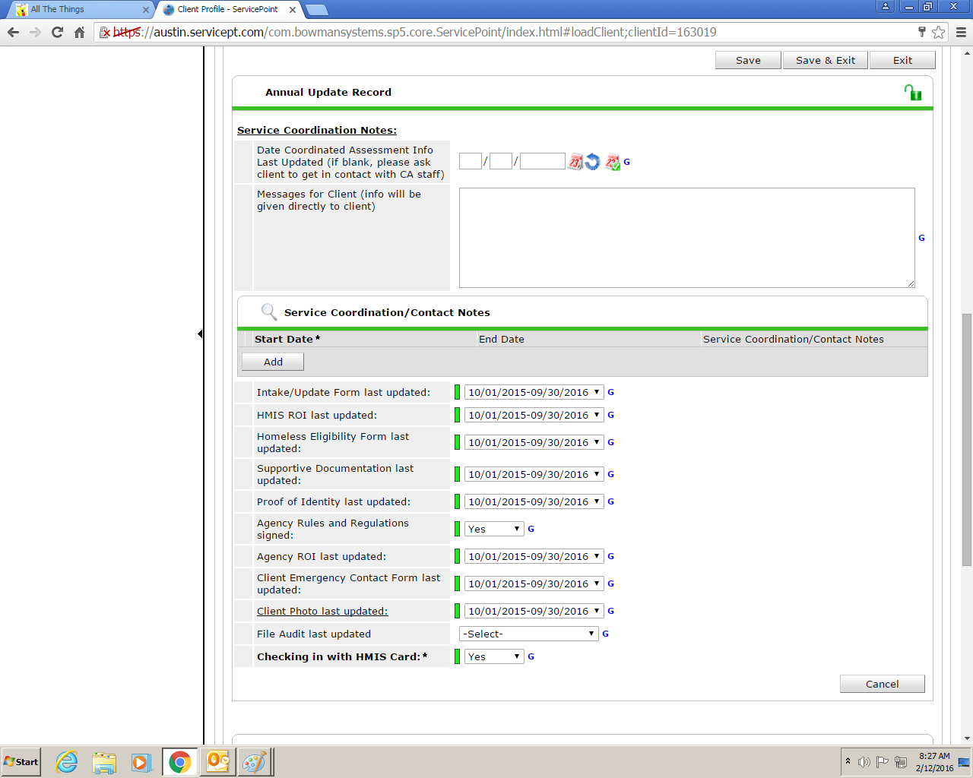
Select the date range between which the date of the intake falls. Complete all fields but “File Audit last updated”. Select “Yes” for “Agency Rules and Regulations signed:” and “Checking in with HMIS Card: Required Field”.
Below this, click “Add New Client Note”. Enter “Issued Card, Agreement Signed – PF”. Please put your initials in place of “PF”.
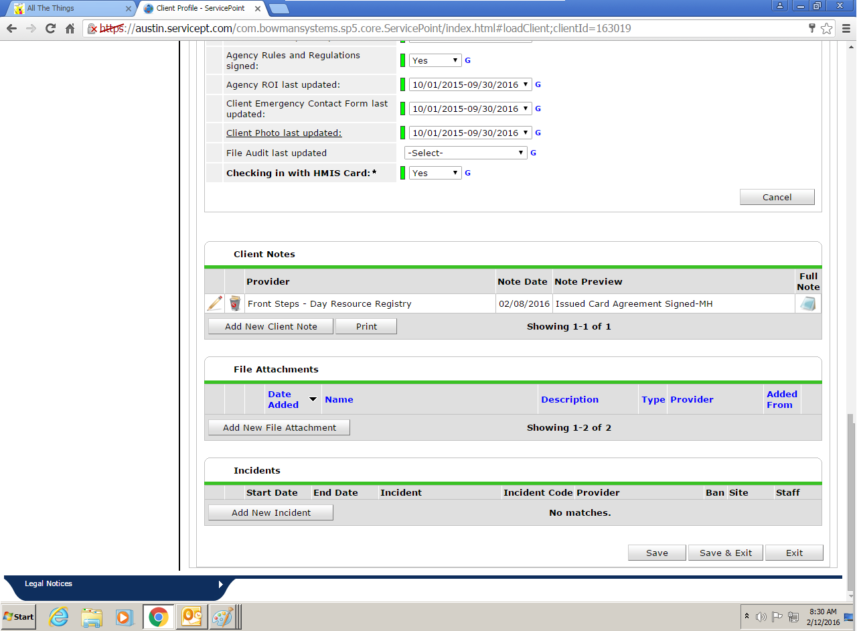
Flip to the next page of the Intake packet and fill out each section. Your name goes next to “Staff Printed Name:”. “Date” should be the date on which this Intake is collected.
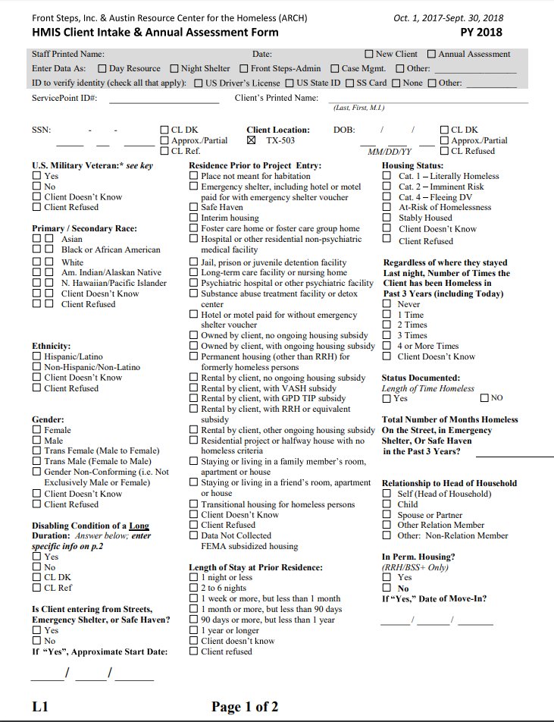
If the information you are entering onto this form is not presented to you via some form of documentation (ie state ID or birth cert), you should ask the client every question on this form. Although things like race and even gender may seem apparent, we cannot assume anything. Often clients will site Hispanic or Latino/Latina as their race. You can let them know that this is classified as “ethnicity” and read off the list of races. Generally people are classified as “White” if they identify as Hispanic or Latino/Latina, but we must record whatever the clients tells us. If, after reading the list, your client doesn’t know, it is okay to check “Client Doesn’t Know”. Please only check 1 box next to a given race. The primary and secondary races should not be the same.
Tip: Clients often do not understand whether their condition counts as a “Disabling Condition of Long Duration”. It may be beneficial to review the list of disabilities on the second page of the Intake form before answering the disabling condition question on the first page. It is important to note that only a long term condition that impairs a client’s ability to live independently (take care of or provide for him/herself) may be considered a “Disabling Condition of Long Duration”.
“Is Client entering from Streets, Emergency Shelter, or Safe Haven?” – If client is staying in a shelter on streets tonight or client does not have a place that could be considered housing to stay tonight, client is entering from streets, Emergency shelter, or safe haven. If client was housed the night before, today/tonight is the start date. In this case, the client will also be considered “Cat. 1” a will have at least one episode of homelessness which will be counted as no less than 1 month. Every time a client is homeless within a month, we count the entire month. If a client is without a place to stay, staying in shelter, on the streets, or in a safe haven for a single night, we count the entire month. If the client is homeless multiple times within a month, we still only count 1 month. If the client is unable to remember the exact date this episode of homelessness began, please help the client estimate. You can also review the “Entry/Exit” tab if this client already had an HMIS profile before you began the Intake.
Breaks in homelessness include staying in a rental by client w/ or w/o housing subsidy for 1 week or longer, staying in a hotel client is paying for w/o emergency voucher for 1 week or longer, staying in friend or family member’s room, apartment, or house for 1 week or longer, staying in hospital or jail/prison for longer than 90 days. Each time your client has experienced one of these, you should count a break in homelessness and, therefore, another episode of homelessness when they return to the streets or shelter.
The client must have a disability that impairs his/her ability to live independently and have been homeless for a continuous 12 months immediately prior to completing this intake or have a disability that impairs his/her ability to live independently and have been homeless 4 or more times over the past 3 year – these episodes adding up to 12 months or more.
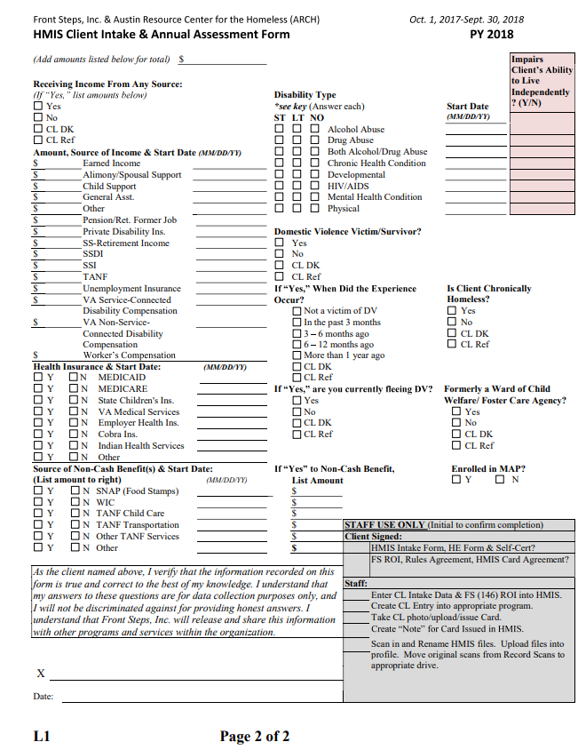
Please enter amount and start date for both Income and Non-Cash Benefits and enter start date for Health Insurance. Please check “ST” (short term), “LT” (long term), or “NO” for all listed disabilities. If you select “ST” or “LT” for any disability, please be sure to enter a start date and a “Y” or an “N” in the field next to the date to show whether the disability impairs the client’s ability to live independently. Pleas initial every line in the grey box on the bottom right. Some of these steps you will complete before the Intake is done. Others you have already completed. Please have the client sign and date at the bottom.
While the client is signing this page, you can complete the required fields on the Client Profile tab.
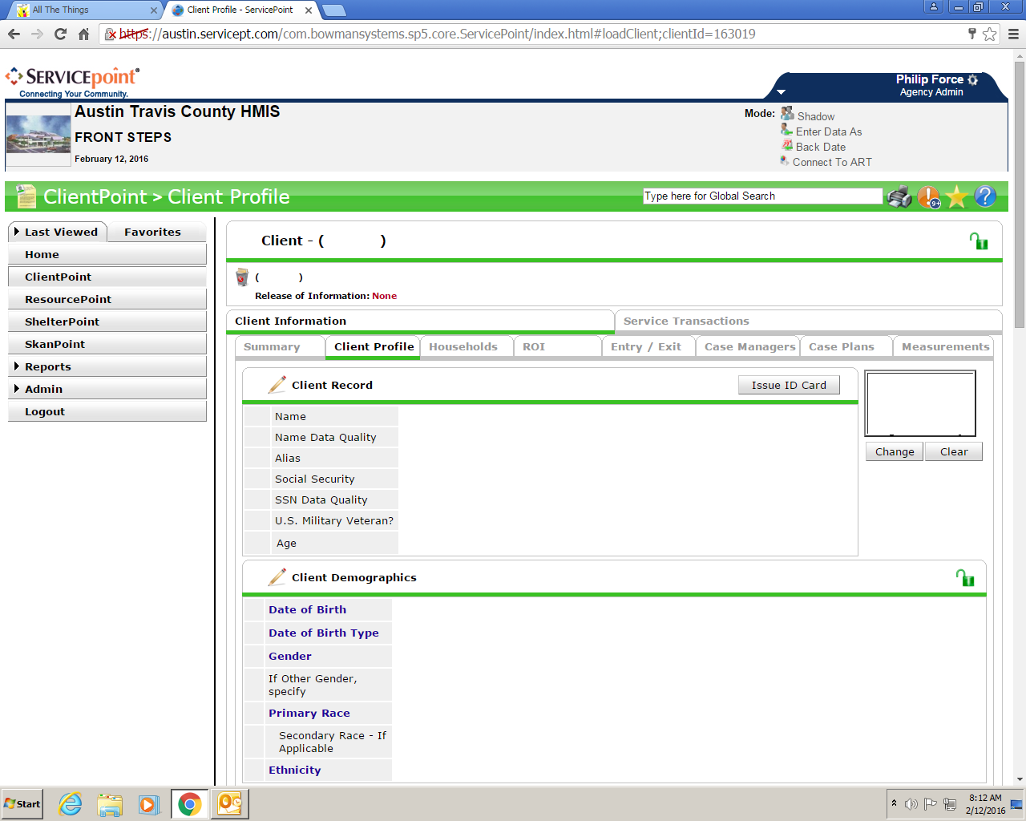Name, Name Data Quality, Social Security Number, SSN Data Quality, U.S. Veteran, Date of Birth, Date of Birth Type, Gender, Primary Race, Ethnicity
create an ROI in ServicePoint. Go to the ROI tab and click “Add Release of Information”.
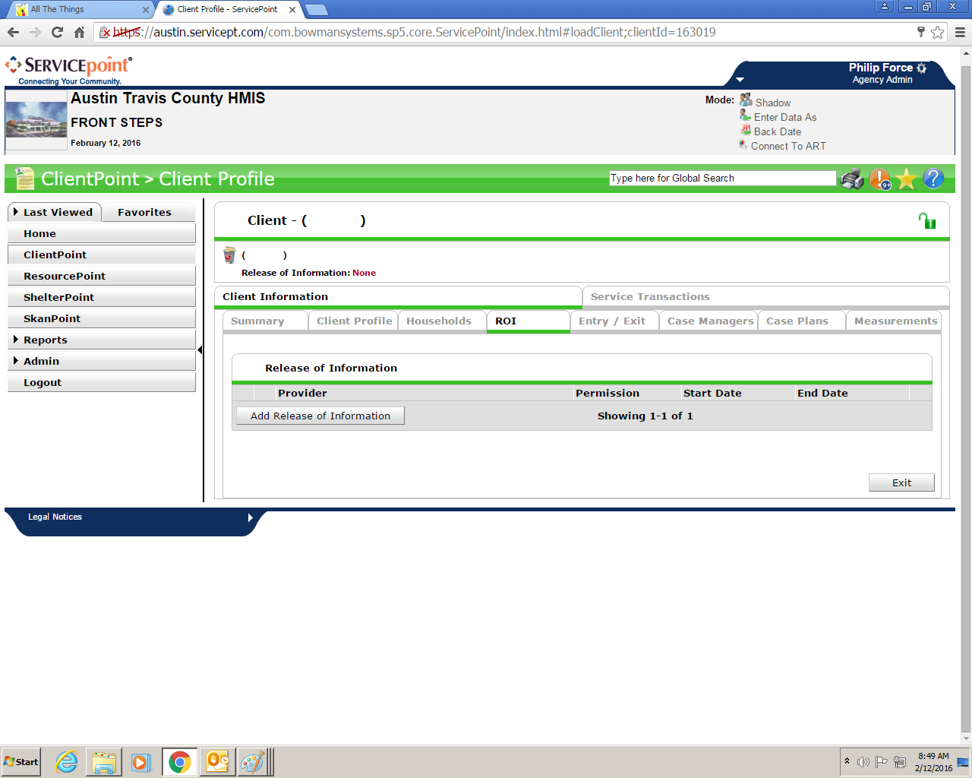

Then your provider should auto-populate. If your Enter Data As is Day Resource, it should say Day Resource. If it is Emergency Night Shelter, it should say Emergency Night Shelter. Select “Yes” or “No” in accordance with where your client initialed on the 3rd page of the ROI. The start date should be the date on which the Intake was done. The end date should be 7 years after the start date. Documentation will be “Signed Statement from Client” and put your initials in the “Witness” field.
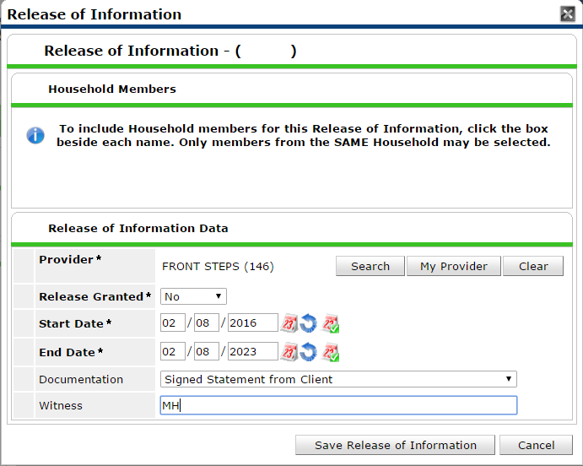

Click “Save Release of Information” and you should see the new ROI as shown in the shot below.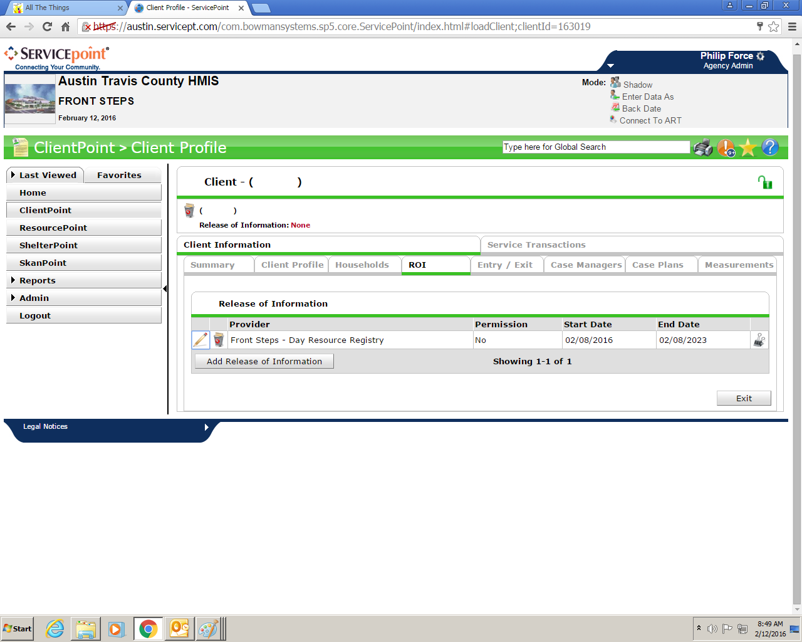

Continue through the Intake packet:
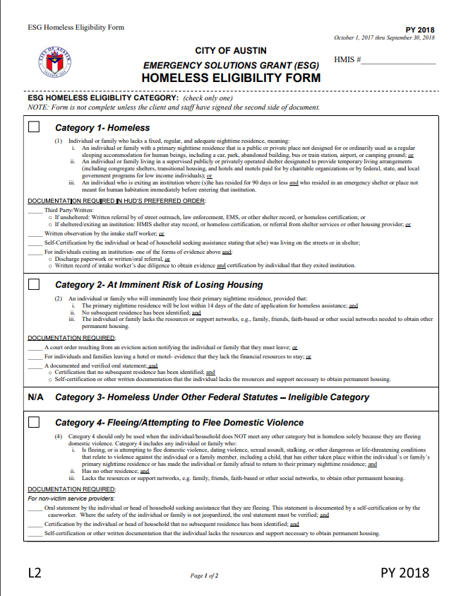
Please print the new ServicePoint number on the top right and check the box next to the appropriate homeless category for the client. If the client is stably housed (see breaks in homelessness description just below the first Intake form page), please write “N/A” in large letters over this form. Remember, if the client is staying on the streets, in a shelter, or in a safe haven tonight or doesn’t know where they are staying tonight, they are considered Cat 1.
If you checked “Yes” for the chronically homeless question on the second page of the intake form, you will need to document either 12 consecutive months or 4 or more episodes adding up to 12 months of homelessness here:
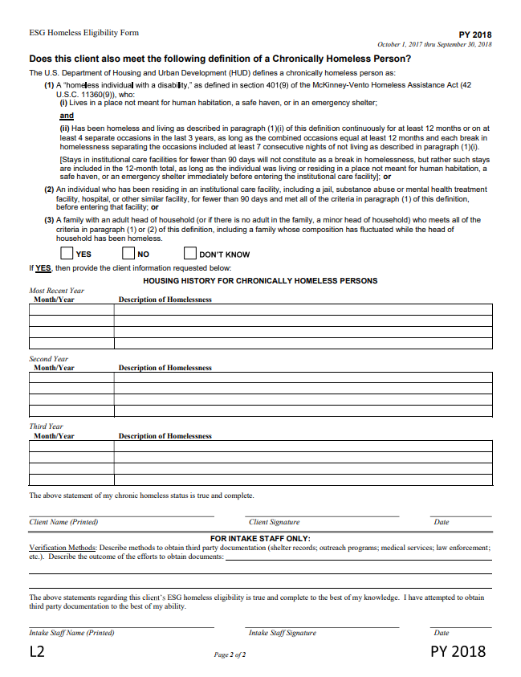
Please check “No” if your client is not chronically homeless and write “N/A” largely across the “Housing History” section. Please check “Yes” if your client is chronically homeless and document where your client was staying and for how long in each section below. Often, clients do not remember specific dates. In this case, it is okay to generalize by year. I’ll often write a year’s timeframe ending with today’s date (ex 01/01/17 – 01/01/18) and then write stably housed, staying on streets, and staying in shelter. Note: We do not need to know in what city or state your client was staying. We are only looking for clues to classification here (Streets or shelter obviously mean cat 1.). Your verification method will always be self-report. Please print your name, sign and date and have your client do the same.
While your client is printing, signing, and dating, you can go to the “Entry/Exit” tab. If there is not already an open entry for your program (Emergency Night Shelter or Day Resource), please create one. If there is already an entry open, please click on the pencil next to the start date.
If you are completing an Annual Assessment, pleas click on the paper icon under “Interims” to the right of the entry open for your program.
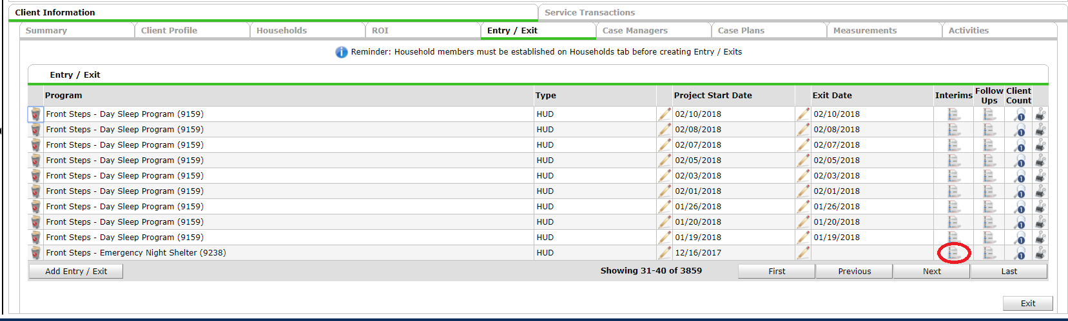If you are doing an Annual Assessment and there is no open entry for your program, please add one and then click the paper icon under “Interims” at the top of the entry pop-up.
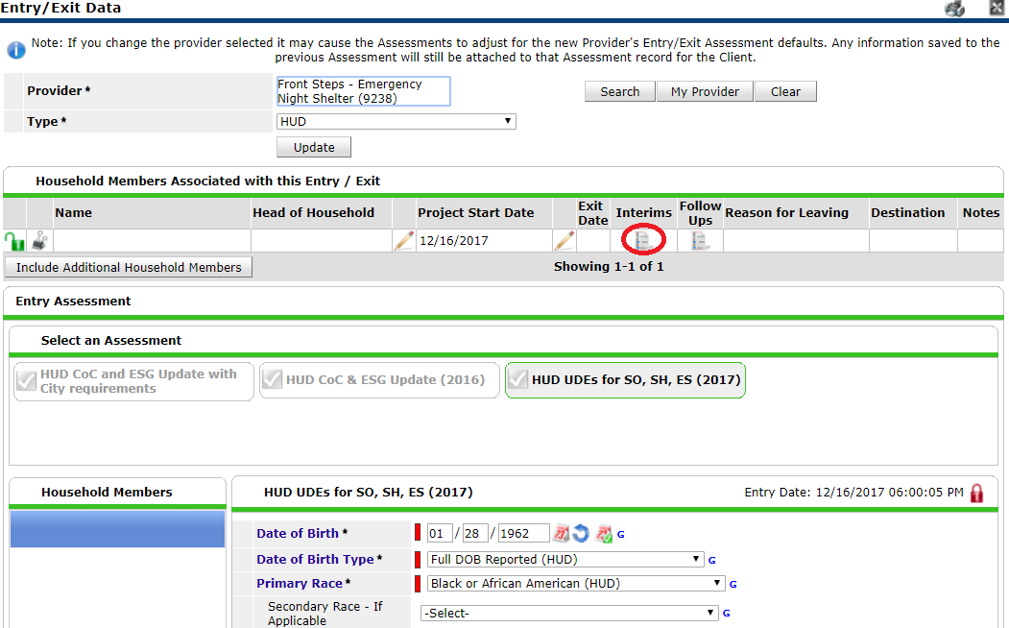
You may now begin entering information collected on the Intake form. Please be sure to enter info for all fields on all 3 tabs.
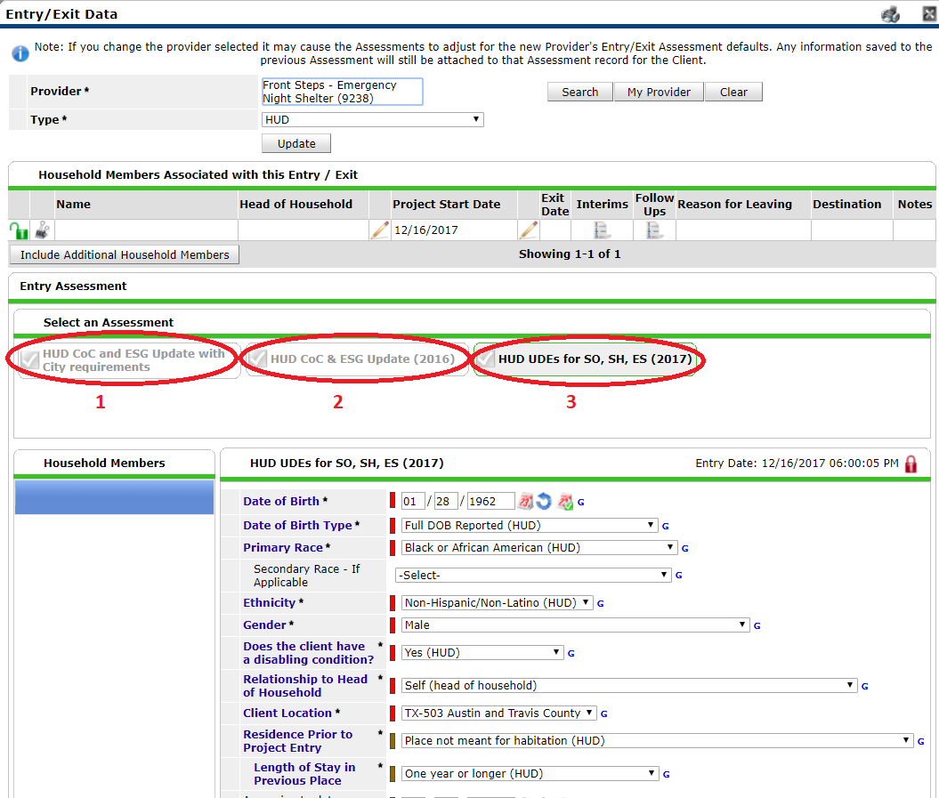

Continuing on the Intake packet:
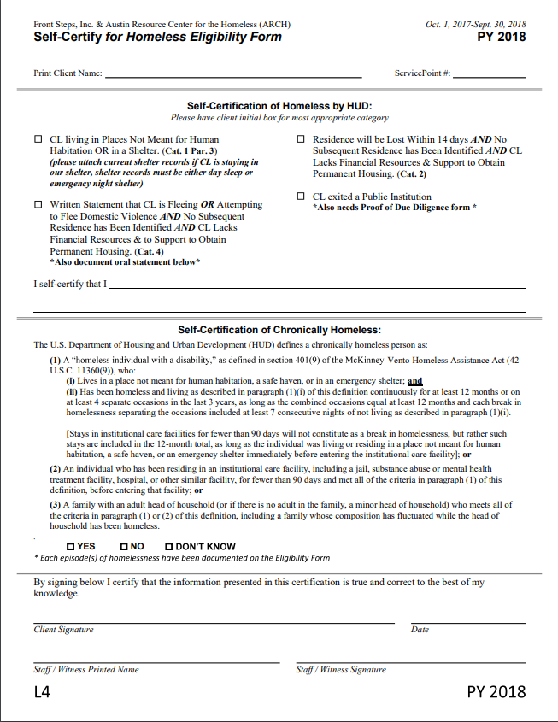
Please enter your client’s name and ServicePoint number at the top, check the box next to the appropriate description of client’s homelessness, and check “YES” if your client is chronically homeless and “NO” if he/she is not.
Then have your client:
Initial next to the box which you checked,
after “I self-certify that I”, print his/her name and write “am homeless”, “am staying in a shelter”, or some other description of his/her homelessness,
and sign and date below the chronically homeless description.
You will then need to print your name and sign at the bottom.

Print your client’s name and ServicePoint number at the top of the “Shelter Rules & Behavior Agreement” form and present it to him/her. 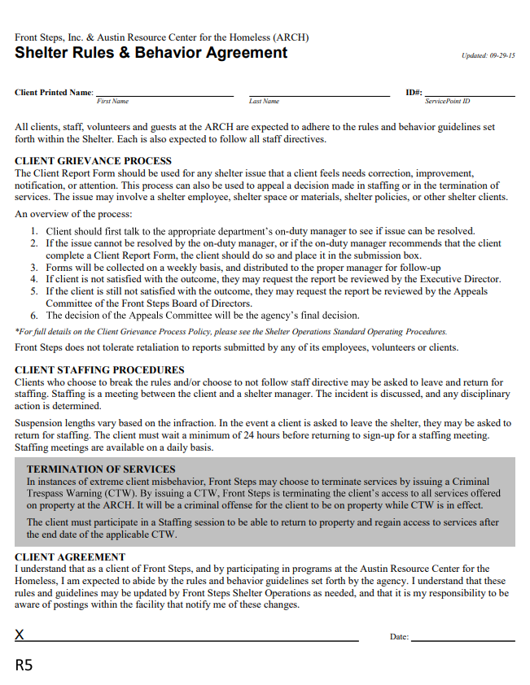
Explain in brief detail the client grievance process and staffing procedures and have your client sign and date at the bottom.
Print your client’s name and ServicePoint number at the top of the “New HMIS Card Agreement” and check the box next to the type of ID provided in the grey box on the bottom right. Present your client with the “New HMIS Card Agreement” form and explain in brief detail what each line says and how to get a replacement. Have your client initial each line and sign and date at the bottom.
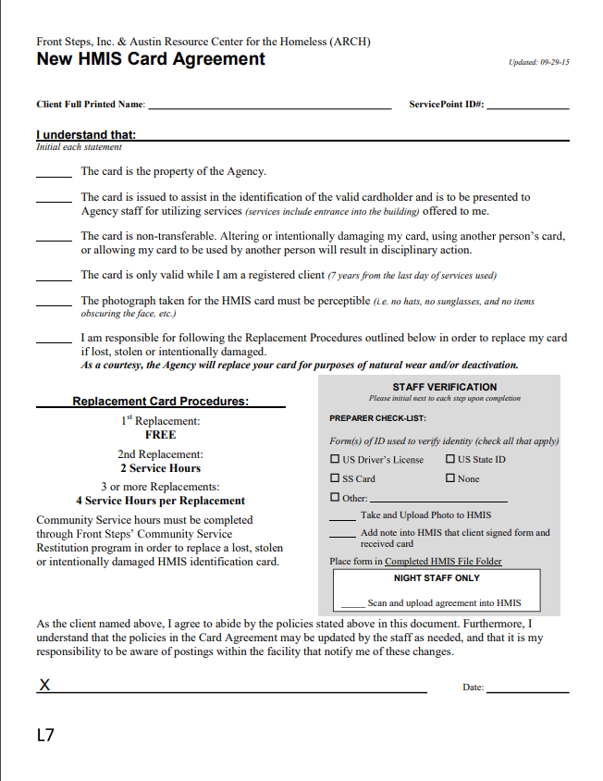

Then take a photo of your client and issue an ID. You can load the Webcam Image Save program from the “Drivers” folder under the “Public Drive”.
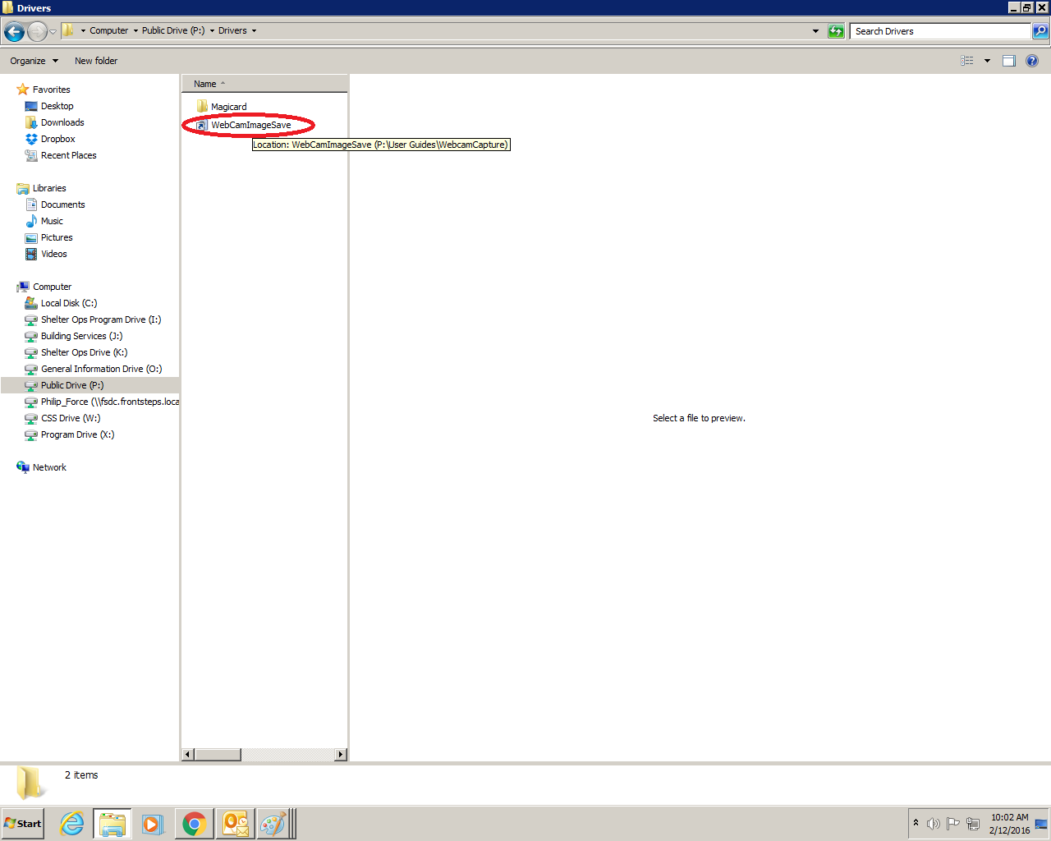
Line up your shot and click “Capture Image Now” from the “File” menu.
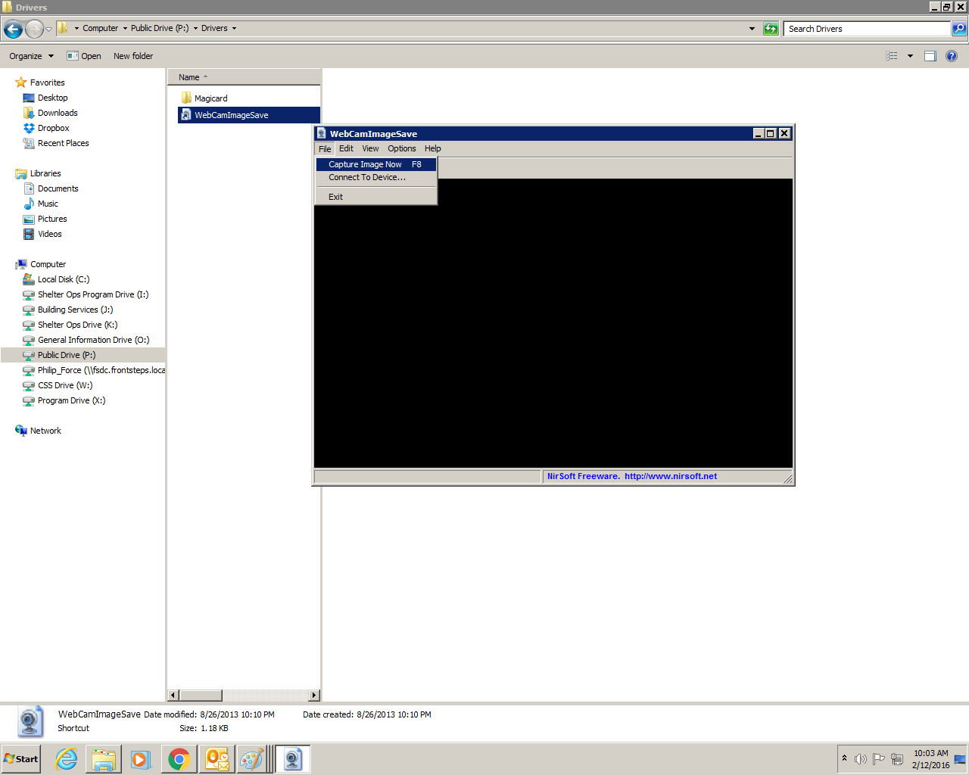
Then, on the “Client Profile” tab of ClientPoint, click “Change” under the Client Photo area, “Choose File”, and “Upload”.
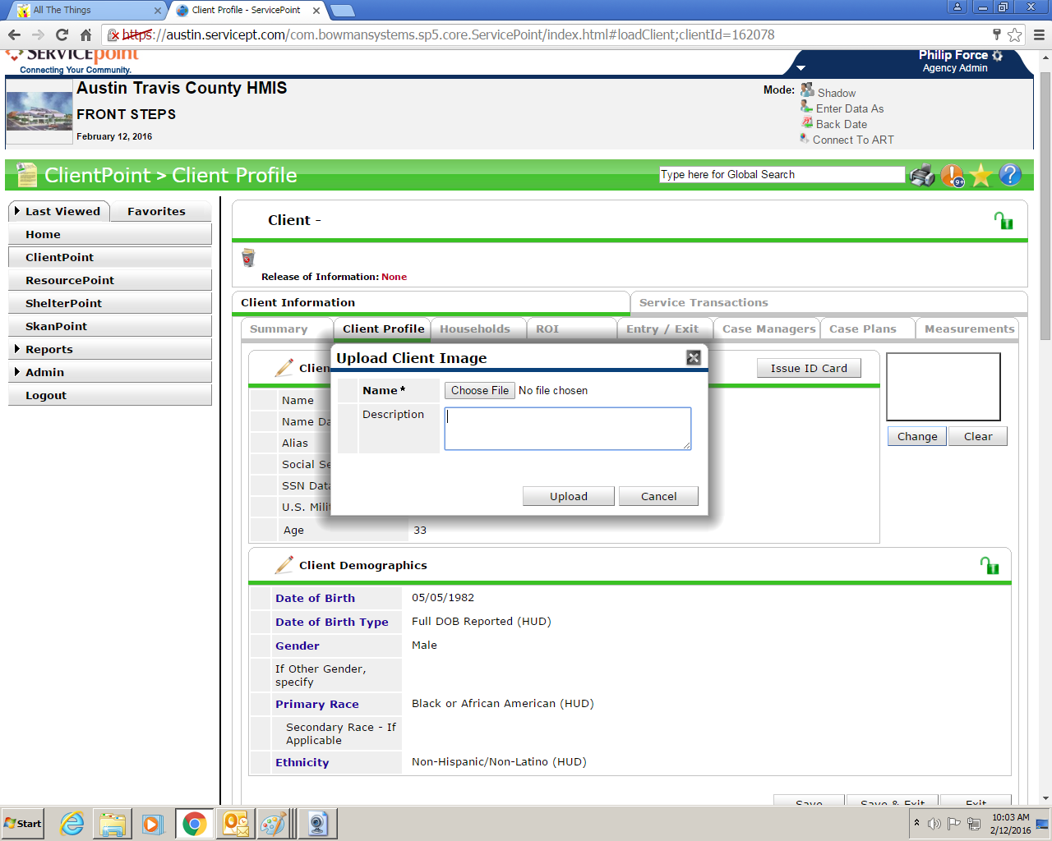
Next, click “Issue ID Card”.
Card options should look like the following screenshot. A client may opt to have his or her Date of Birth printed on the card as well.
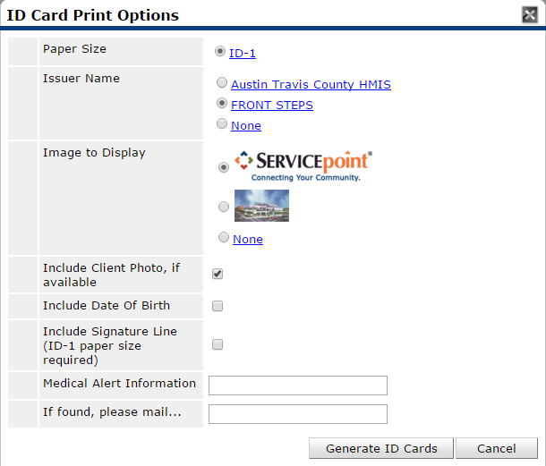
Click “Generate ID Cards” and right-click to print.
Now it is time to rename and upload your Intake and ROI. Please scan the HMIS ROI and the Intake as separate documents. You will want to rename the Intake packet and ROI using the following formats: Lastname, Firstname_SPNumber.INTK_PT.010118 and Lastname, Firstname_SPNumber.ROI.010118. Next upload the Intake under “File Attachments” under the “Client Profile” tab. To do so, click “Add New File Attachment”
Click “Choose File”.
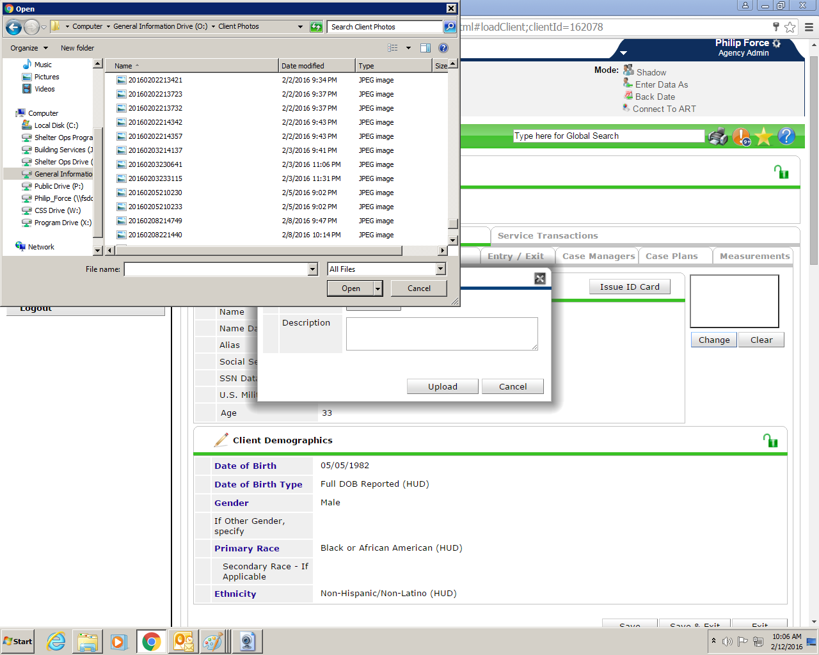
Select the INTK_PT file and click “Open”.
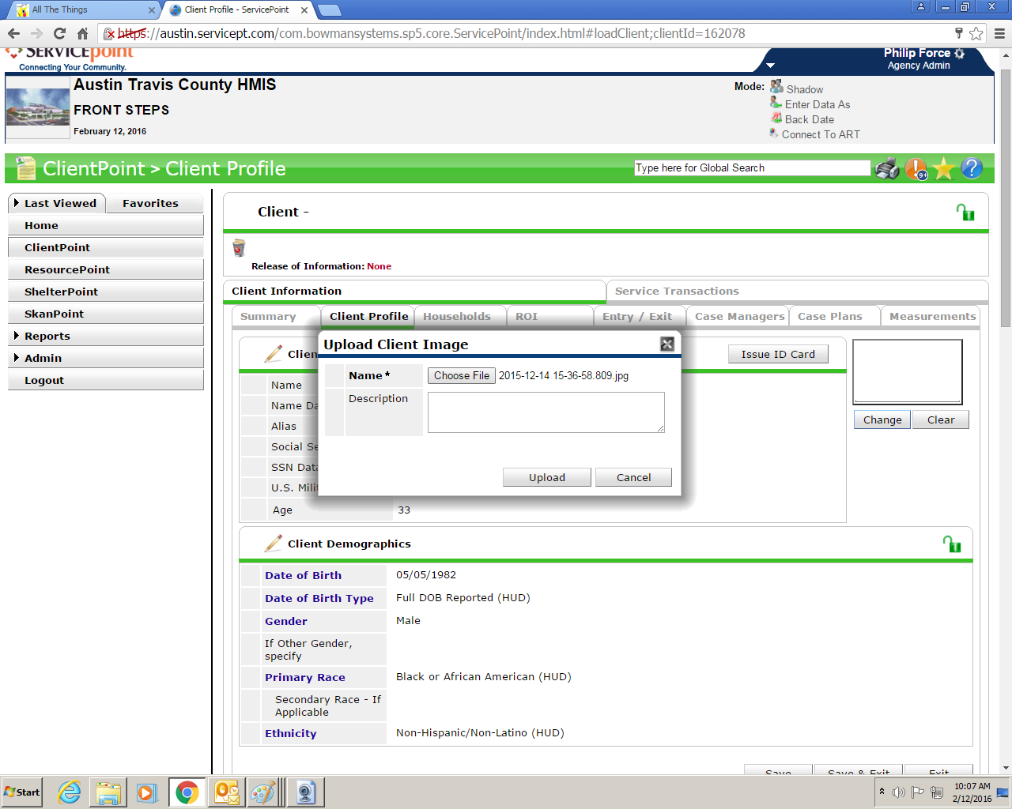
Then click “Upload”.
Then go to the ROI tab and click the paper/binder-clip icon to the right of the ROI you created.
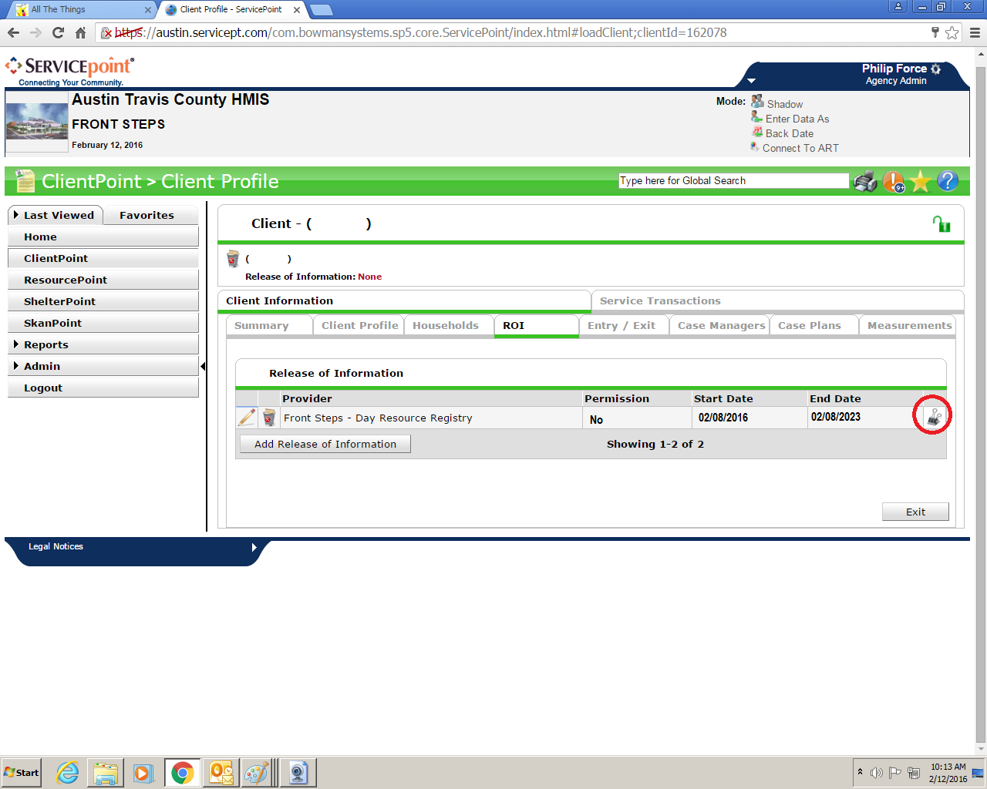
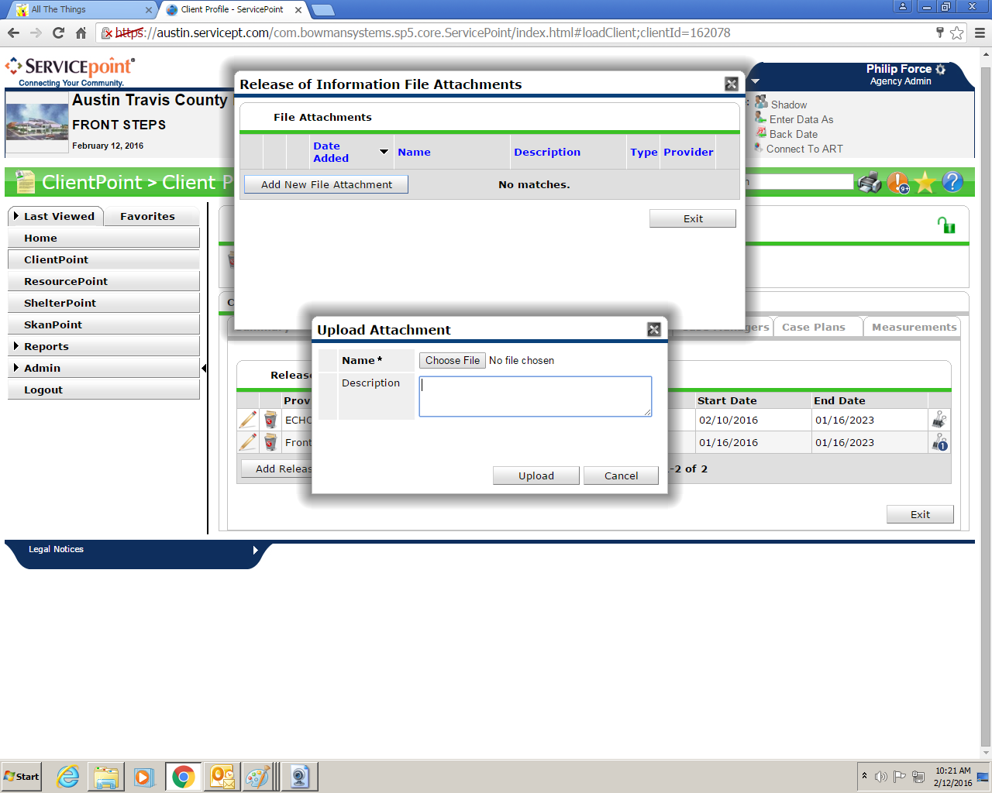
As on the Client Profile tab, here you will click “Add New File Attachment” and then browse by clicking “Choose File”. Don’t forget to click “Upload” once you’ve selected the file.

